FACULTY RESOURCES
Faculty Resources  provost.tcu.edu/faculty-resources | 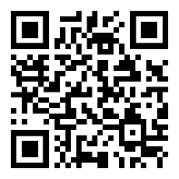
Faculty FAQs  provost.tcu.edu/faq | 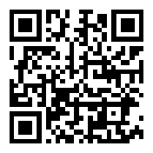
Academic Affairs Policies & Procedures  provost.tcu.edu/faculty-resources/academic-affairs-administrative-handbook | 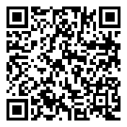
Handbook for Texas Christian University Faculty and Staff  tcu.edu/files/Faculty-Staff-Handbook.pdf | 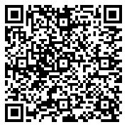
Faculty Senate
fsn.tcu.edu

Faculty180 and Annual Report  provost.tcu.edu/faculty-resources/faculty180 | 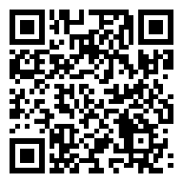
Koehler Center for Instruction, Innovation & Engagement  cte.tcu.edu | 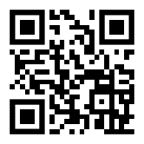
TCU Portal  my.is.tcu.edu | 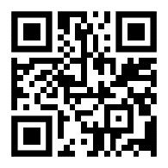

DEPARTMENT
Departmental Policies and Procedures

Office Hours

Committees and Meetings

Department Academic Misconduct Action

LOGISTICS
Your Office Phone  it.tcu.edu/ringcentral | 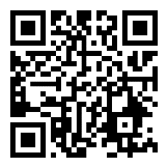
Travel Reimbursement and Advance Procedures  vcfa.tcu.edu/financial-services-forms | 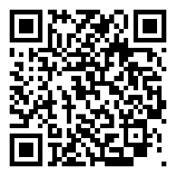
Access to the Office Building After Hours and Card Swipe Access
Copier Codes and Use

NOTES

FACULTY ROLES, RESPONSIBILITIES, AND EXPECTATIONS
Teaching Load and Courses
Academic Misconduct  deanofstudents.tcu.edu/student-handbook/academic-policies/academic-conduct-policy | 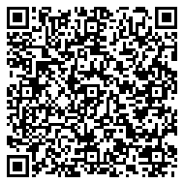
Dean of Students  deanofstudents.tcu.edu | 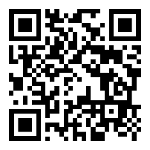
Final Exam Expectations | Faculty Staff Handbook page 63
Student Complaints | Faculty Staff Handbook page 61
Textbook Adoptions
Department Grading Expectations
Athletes and Making Up Assignments
Midterm and Final Grades
FERPA and Common Questions or Scenarios
College Testing Center
Research and Creative Activity (as applicable)
Service
Evaluation (as applicable)
SPOT  ir.tcu.edu/spot | 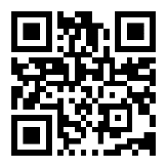
Peer Review of Teaching and Classroom Observations  cte.tcu.edu/services/classroom-observations | 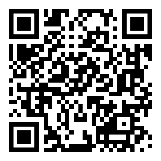
Promotion and Tenure, Annual Review, and Post-Tenure Reviews  provost.tcu.edu/faculty-resources/tenure-promotion | 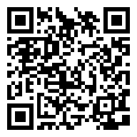
Promotion & Annual Reviews

