*[Use the following to send to your students.  Please change the fields in RED with your class and password information.]*

# Online Support and Training

[Student Quick Start Guide](https://guides.turnitin.com/01_Manuals_and_Guides/Student_Guides/01_QuickStart_Guide)

# Create a user profile (New Users)

1. Go to [www.turnitin.com](http://www.turnitin.com) and click “Login” at the top of the page.
2. Under the login box select the link for “Would you like to create your user profile?”
3. At the bottom of the page under Create a New Account, select Student

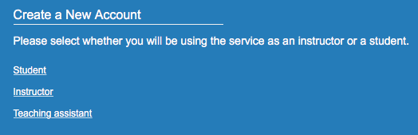

1. Use the Class ID and Enrollment password below to create your account.  The Class ID and Enrollment password assigns you to the correct Professor’s course.

Use the following for this class:  
Class ID:  **provided by instructor**  
Enrollment password: **provided by instructor**

1. Enter your first name, your last name, and your TCU e-mail address (this will be your user name)
2. Enter (and re-enter) the password you would like to use as your Turnitin login password
3. Select a secret question using the secret question pull down menu, enter an answer
4. Review the Turnitin user agreement and click to agree and finalize user profile creation
5. Click to exit the profile creation wizard and sign in to Turnitin

# Login to TurnItIn

1. Go to [www.turnitin.com](http://www.turnitin.com) and click “Login” at the top of the page.
2. Enter your TCU e-mail address and user password.
3. Click Login to open your Turnitin homepage.

# Enroll in a Turnitin Class (existing users)

Students with pre-existing user profiles can use the enroll in a class

tab to enroll in additional classes.

1. After logging in, click on the "enroll in a class" tab on your student homepage

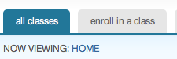

2. Enter the class id and enrollment password provided by your instructor.

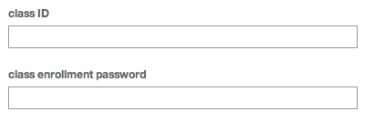

3. Click submit to enroll in the class

**submit**

# Submitting a Paper

Your class will show up on your homepage. Click on the name of your class to open your class portfolio

**Screen shot 2010-10-15 at 11**

Click on the name of your class to open your portfolio

Your class portfolio shows the assignments your instructor has created and your submissions to the class. To submit a paper, click the submit button next to the assignment’s title.

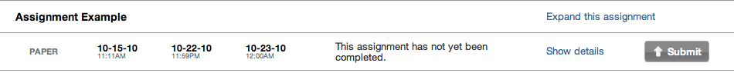

*Click the submit icon to upload your paper*

The paper submission page will open. Enter a title for your paper. To select a paper for submission, click the *browse* button and locate the paper on your computer. We accept submissions in these formats:

• MS Word, WordPerfect, RTF, PDF, PostScript, HTML, and plain text (.txt)

After entering a title for your paper and selecting a file, click *submit* to upload your paper



Once you have located your paper and entered a title, click submit

If your paper is in a format that we do not accept, you can submit it by cut and paste. To submit a paper this way, select *cut & paste* using the pulldown at the top of the form 5.



*Select cut & paste with the pulldown to submit a paper in a file format we do not accept*

To submit a paper by cut and paste, copy the text of your paper from a word processing program and then paste it into the text box in the submission form. If you submit your paper using the cut and paste method, you can skip the next step.

The paper you chose to submit will be shown on the next page. Look over all the information and make sure that it is correct. To confirm the submission, click the *Submit Paper* button 6.



*Make sure you selected the correct paper; click “Submit Paper” to finalize your submission*

After you confirm your submission, a digital receipt will be shown. This receipt will be e-mailed to you. To return to your portfolio and view your submission, click the portfolio button

# Viewing Your Submissions

After you submit a paper, it will appear in your class portfolio next to its assignment. Every paper you submit can be viewed online by clicking on its title in your portfolio. You can download a paper to your computer in file format by clicking on the file icon

Papers submitted to Turnitin are compared against billions of internet documents, an archived copy of the internet, our local databases of submitted student papers, and a database of periodicals, journals, & publications. Any matching text we find is detailed in an Originality Report sent to your class portfolio.

**You will be able to view Originality Reports only if your instructor has given you permis­sion to access them.**